ECE 3720

Microcomputer Interfacing Laboratory

Section 6

Timothy Driscoll

Date Performed: September / 5 / 2019

Lab 1

ABSTRACT:

Lab one is designed to introduce how to program, compile and run code on the MPLAB X IDE software for the PIC32MX150F128D microcontroller.

**INTRODUCTION:**

In this lab, we took time to review the general lab procedures and the basics of how to program, run and compile the code using the MPLAB X IDE software. The lab gave us a basic understanding of some of the key tools in the IDE software and how we can edit our code. The lab also gave a focus on our available resources including the “chipKIT Cmod Reference Manual” and the “PIC32 Datasheet”.

**EXPERIMENTAL PROCEDURES:**

In this lab, we started by accessing the necessary code from a file on canvas. After downloading the code and unzipping the folder we opened it in the MPLAB X IDE software. We then determined what to open in order to access the C code for the lab. After accessing the code, we learned some of the basic tools within the IDE which included how to compile and make some small changes to the code. Some of the changes that we looked at within the code involved altering for loops to adjust the clock speed and reverse the order of the count.

**RESULTS and DISCUSSION:**

There is no discussion for this week.

**CONCLUSSION:**

We have concluded that throughout the course of this lab we will be using the MPLAB X IDE in order to program, run and compile all the necessary code for the labs. This will then be paired with the wiring of the microcontroller and the NI ELVIS in order to perform the labs and achieve the desired outputs and results. Lastly, we concluded that that the provided documentation of the PIC32MX150F128D microcontroller will be needed in order to correctly determine what pins should be used when wiring the microcontroller.

**REFERENCES:**

Clemson University’s ECE 372 Lab 1 Powerpoint.

**FIGURES AND TABLES:**

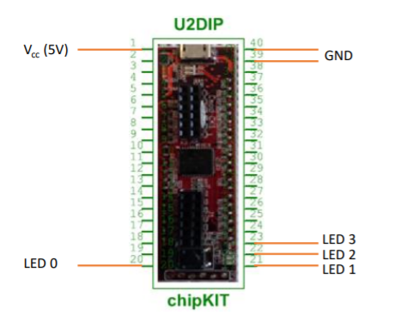

**Figure 1: Wiring for lab 1 (Pin connections described in experimental procedures)**

**CODE:**

#include <plib.h>

delay(){

int i, j;

for(i = 0; i < 500; i++)

for(j = 0; j < 500; j++);

}

main(){

int count = 0;

TRISB = 0x00; //Set all pins to output.

while(1){

LATB = count; //Output count to B

count++;

if(count > 15)//Restrict count to 0-15, needing only 4 bits

count = 0;

delay();

}

}